-- task : 1 join multiple tables using left join

select co. country_name, cu.customer_name,ci.city_name

from country as co

left join customer as cu

on co.id = cu.id

left join city as ci

on co.id = ci.id;

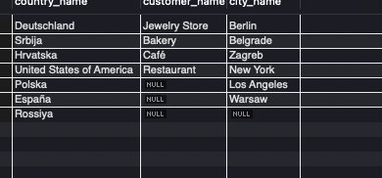

-- task 2: join multiple tables using both left and inner join

select co.country_name,ci.city_name,cu.customer_name

from country as co

join city as ci

on co.id = ci.id

left join customer as cu

on co.id = [cu.id](http://cu.id);

